
Excursions
PANIC05
Wednesday, October 26, 2005

The Walking Tour of Los Alamos includes a delicious lunch at the renowned restaurant Gabriel’s, where guests will enjoy a traditional Mexican lunch, a short walking tour, and a guided tour of the Bradbury Museum where videotapes, videodisks, interactive computer programs, a Mark 12A warhead, models of Vela and Navistar verification and communication satellites, and an air-launched cruise missile are housed. You will visit Los Alamos Historical Museum, Fuller Lodge, and the Ice House Memorial, originally used to store classified exhibits. Historic Pathway is wheelchair and scooter accessible.

El Santuario de Chimayo, the legendary shrine believed to be built on sacred earth is one of the most visited in the United States. Guests will board a luxury motor coach with expert guides as you drive through some of the most beautiful scenery Northern New Mexico has to offer. This tour will include a meal at Rancho de Chimayo, known internationally for its unique Mexican cuisine and beautiful atmosphere, a guided walk through the historic Plaza and the miraculous santuario, and visits to famous weaver’s studios of Chimayo for a glimpse at this centuries old art form.
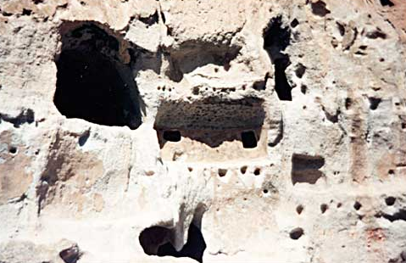
Bandelier National Monument is best known for mesas, sheer-walled canyons, and the ancestral Pueblo dwellings found among them. Guests will board a deluxe motor coach where coolers of iced waters will be available. As you depart, expert, native guides will give an informative talk about what will be seen at the monument. This tour will include a boxed picnic lunch beneath the cottonwood trees and a guided hike through Frijoles Canyon where you may climb ladders to the cliff dwellings and actually enter the pre-historic homes for an unforgettable experience.

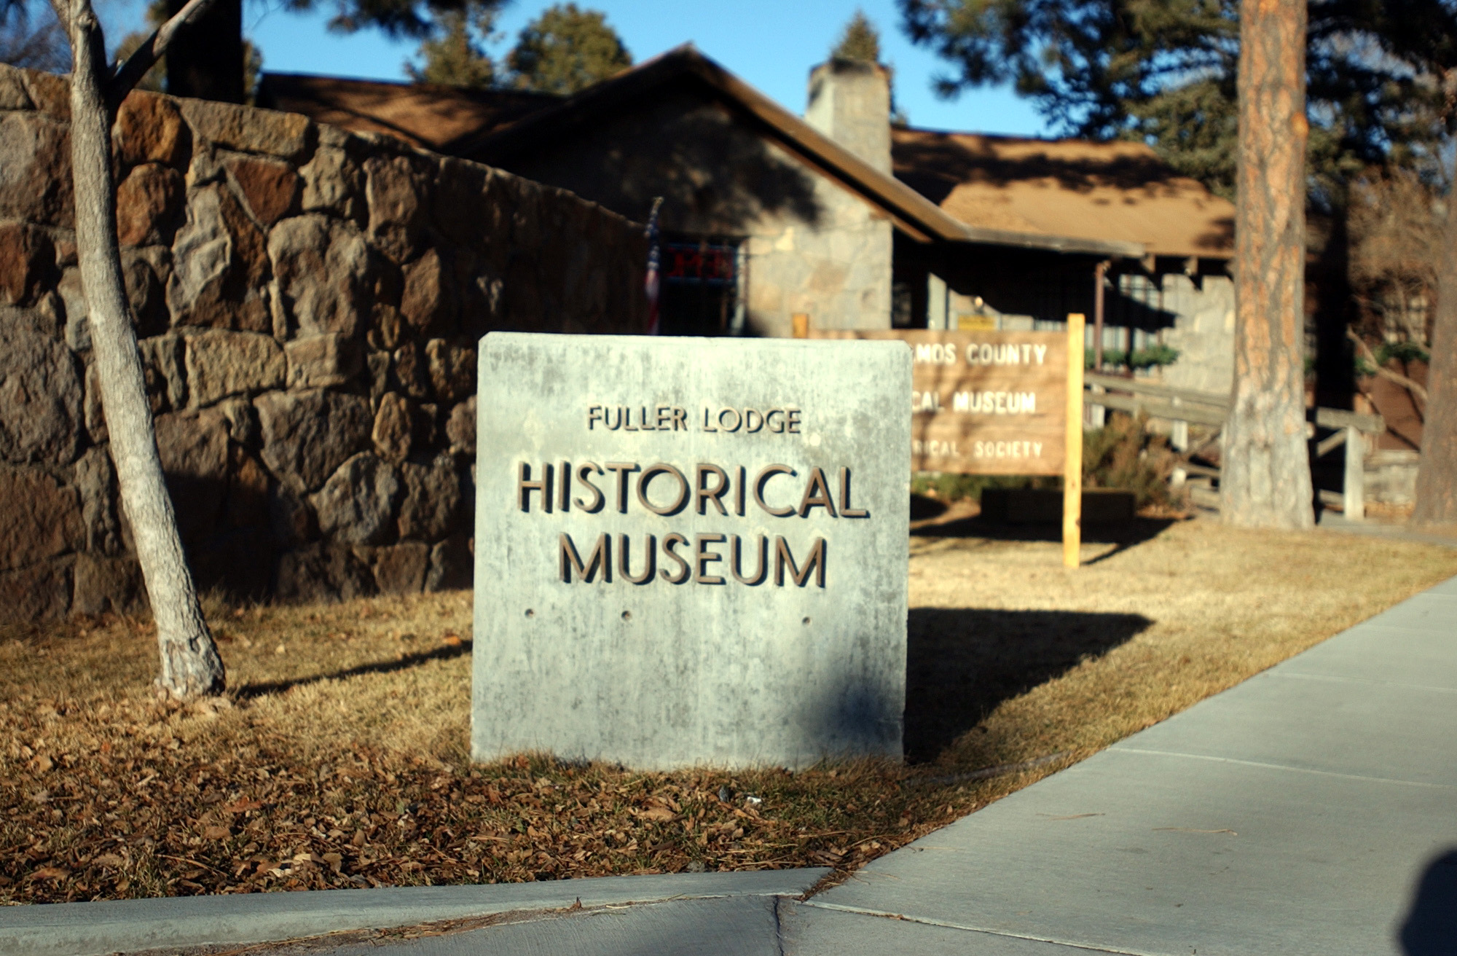
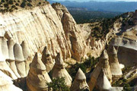
The buses for the four excursions will depart from the Hilton Hotel. Loading of the buses will be from 12:15pm–12:35pm with a prompt departure at 12:45pm.

Per person pricing based on minimum of 50 people: $45.00 Includes: deluxe transportation, expert native guides, entry fees, gourmet lunch, iced waters on board coach, and all tax and gratuities.

For more information:
http://panic05.lanl.gov/index.php?link=excursions

Approximate Tour Length: 5 hours

Attire: Comfortable walking shoes, layered casual outdoor wear, camera, sunscreen, hat or cap

Tent Rocks National Monument offers spectacular scenery and a hike through amazing rock formations. Wind and water wore into volcanic deposits across the Pajarito Plateau, creating canyons and arroyos. In places, the walls of the canyon are 200 feet high. Our expert guides will accompany you during the hike pointing out various petroglyphs and geological points of interest. This tour includes a brief hike into the canyon, a detour into a broad amphitheater surrounded by banded cliffs, as well as a gourmet, boxed picnic lunch.

