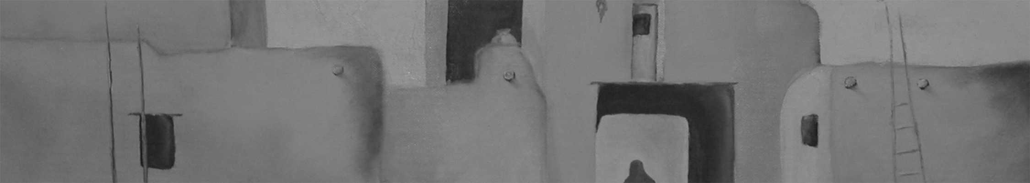
Public Science Lecture
PANIC05
October 2005

Lensic Theater, October 25, 8:00 pm – 10:00 pm

Dr. Wendy L. Freedman
Director
Carnegie Observatories
Pasadena, California

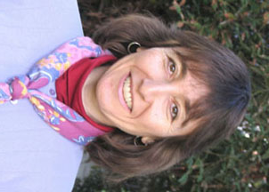

The Accelerating Universe
Recent measurements have led to a new model in cosmology. In this model, the universe is geometrically flat and accelerating, one third of the matter-energy density is matter, most of which is dark matter, and the remaining two thirds is in the form of a mysterious dark energy component. I will discuss the evidence for this current model, its successes and challenges, the interface between cosmology and particle physics, and the ongoing and future experiments aimed at improving the precision with which cosmological parameters are measured.

Dr. Wendy Freedman is an astronomer and the Crawford H. Greenewalt Director at the Carnegie Observatories in Pasadena, California. A native of Toronto, Canada, she received her doctorate in astronomy and astrophysics from the University of Toronto in 1984. She received a Carnegie Fellowship at the Observatories in 1984, joined the permanent faculty in 1987, and was appointed Director in 2003. Dr. Freedman received the 1994 Marc Aaronson Lectureship and prize, and in 1999 was selected as an American Physical Society Centennial Lecturer. In 2000 she received the McGovern Award for her work on cosmology and was elected a Fellow of the American Academy of Arts and Sciences. In 2002 she was awarded the American Philosophical Society's Magellanic Prize and in 2003 she was elected to the National Academy of Sciences.

Dr. Freedman’s principal research interests are in observational cosmology. She was a principal investigator for a team of thirty astronomers that carried out the Hubble Key Project to measure the current expansion rate of the Universe. Her current research interests are directed at measuring the past expansion rate of the Universe, and in characterizing the nature of dark energy, which is causing the Universe to speed up its expansion.

